NCHRP 20-07 Request
Exploration of a Resource Center for a Congestion-Free America
(Operations Center of Excellence)
Submitted by AASHTO Highway Subcommittee
on System Operations and Management

BACKGROUND
The AASHTO Standing Committee on Highways’ Strategic Plan’s fourth objective is to “strive to create a congestion-free America by integrating advanced technologies and enhanced operations to efficiently manage the multimodal transportation system, while strategically adding capacity with a focus on improving the performance of the overall system.” Action Item 2 for this objective is to “advance innovative operations to improve system performance by identifying best practices on emerging initiatives and organizational structures appropriate to facilitate broad implementation. SCOH will also explore the creation of a Resource Center to facilitate broad implementation of best practices.”
Many states have gained experience with innovative technologies and techniques that would be beneficial to other states in reducing congestion. There are several, sizeable efforts underway to develop new technologies and techniques (e.g., U.S DOT’s development of the IntelliDriveSM program, SHRP2 track for reliability, NCHRP project developing an AASHTO Guide for Systems Operations and Management, etc.). Information on these efforts and others are difficult to find. A Resource Center (Operations Center of Excellence) will help transportation agencies identify and assess innovative technologies and techniques and be a one stop shop for Operations.
OBJECTIVE
A Center for Excellence (COE) for Operations would be designed to promote collaboration and using best practices to develop and implement applications. The COE would be a resource center that provides a library of materials, industry best practices, procedures and advice. It would draw upon expert knowledge and experience from the industry’s preeminent research centers, university transportation centers and results from research programs.
The COE could be responsible for the following:
- Supporting the industry sector through services needed and providing subject matter experts
- Providing guidance by being a knowledge repository for standards, methodologies, tool development and implementation, promoting collaboration, and applying best practices
- Promoting shared learning through training, certifications, skill assessments, team building and formalized roles to encourage shared learning
- Using measurements to demonstrate delivered value and results
- Providing governance by allocating limited resources
The Subcommittee on Systems Operations (SSOM) could be the governing body over the COE. The SSOM’s level of governance may have limited input in some areas while establishing and enforcing standards in other areas depending on the need. Other subcommittees could be responsible for implementation of identified excellence tracks (application areas) within state DOTs.
A governance structure, business model, operating guidelines, charter, membership structure, and funding mechanism need to be developed as part of this research. Conceptual thoughts:
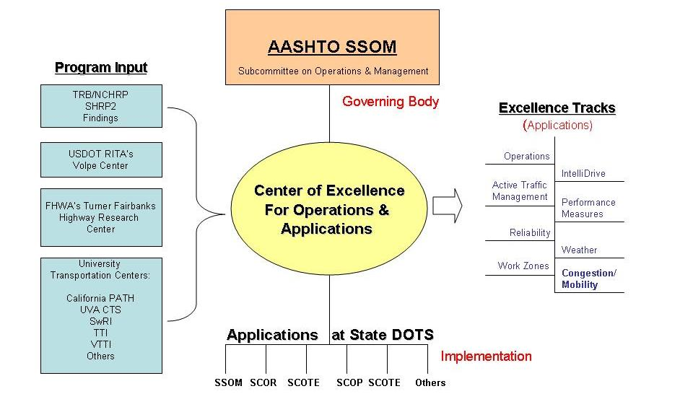

This concept and other business models for building and sustaining the COE need to be fully evaluated to determine the long term sustainability and applicability.

FUNDS REQUESTED: $90,000

SUBMITTED BY:
Scott Rawlins, P.E. (SSOM Chair)
Nevada Department of Transportation
Deputy Director/Chief Engineer
(775) 888-7440

